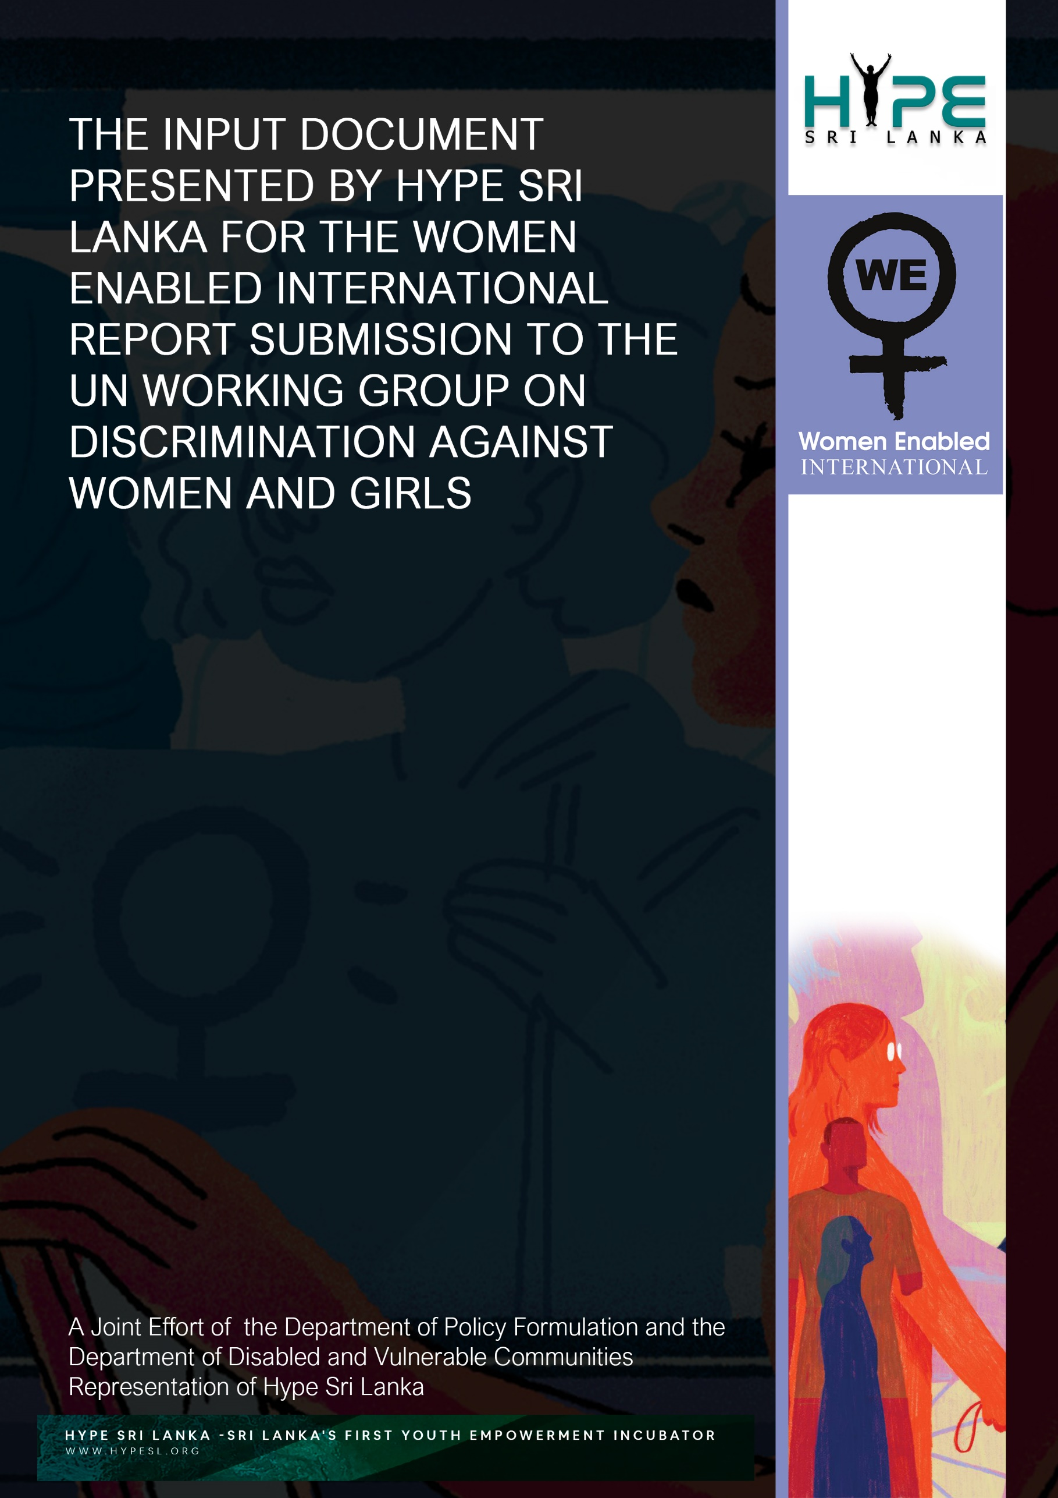

FOREWORD

This Input Document is jointly compiled by The Department of Policy Formulation and The Department of Disabled and Vulnerable Communities Representation of Hype Sri Lanka, at the invitation of Women Enabled International (WEI) for the Review Report being submitted by WEI to The United Nations Working Group on Discrimination Against Women and Girls. The situation analysis and recommendations provided in this document are a representation of the observations made during one-on-one consultations organised by Hype Sri Lanka, with key focal points and leaders in the national disability empowerment ecosystems of the Country. The Input Document is from the localised perspective and experiences of Sri Lanka. The Proposed Text which is presented under each sub heading of this document contains the main highlights of each section which Hype Sri Lanka believes should be extracted and appropriately included in the final Review Report presented by WEI.
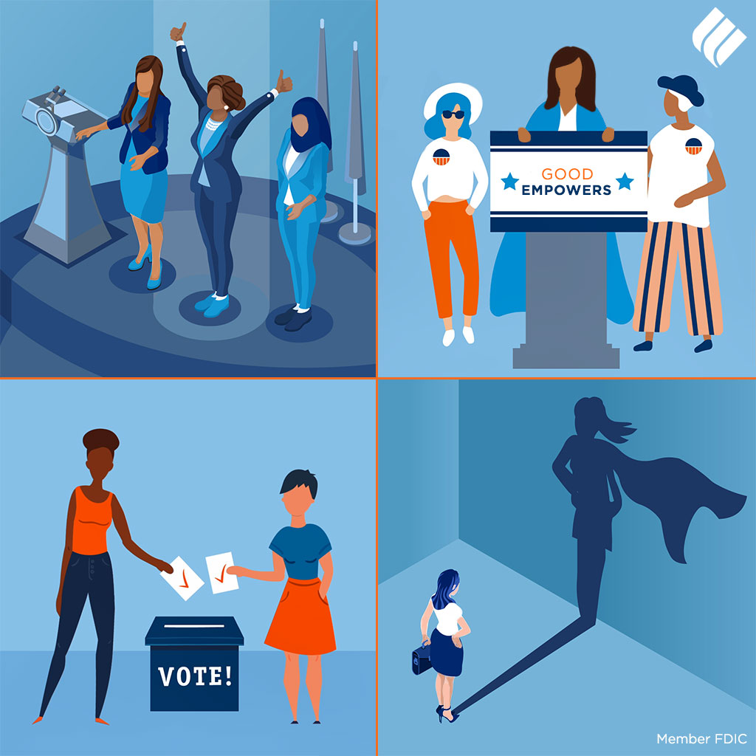

CONTENTS

CONTENT | PAGE NO
List of Consultations | 3 - 4
List of Abbreviations | 5
Research Findings | 6 - 18
1. Intersectionality of The Feminist Movement to the Needs of Women with Disabilities | 6 - 7
2. Accessibility Challenges of Women with Disabilities to Public Political Spaces and Advocacy in Sri Lanka | 8 -10
3. Understanding of Women with Disabilities of Individual Political Rights | 10 - 11
4. Lack of Access to Justice and Reparations for Women with Disabilities | 12 - 13
5. Access to Technology for Activism of Women with Disabilities | 13 - 14
6. Threats and Risks Faced by Women with Disabilities Engaging in Public and Political Spaces | 14 - 16
7. Impacts of the COVID-19 Pandemic on The Public Political Participation and Advocacy of Women with Disabilities | 16 - 17
8. Inclusion of Women with Disabilities in Human Rights Activism | 17 - 18
Acknowledgements | 19 to 20

LIST OF CONSULTATIONS

No. | Name of Consultant | District of Residence | Brief Profile of The Consultant Profile | Date of The Consultation | Time
Consultant 1 | Dr. Samitha Samanmalee | Colombo | Medical Officer who is a physically disabled. | 28th September 2021 | 7pm - 8 pm
Consultant 2 | Ms. Lasanthi Daskon | Colombo | Independent Disability Rights Activist | 4th October 2021 | 5.30pm - 6.30pm
Consultant 3 | Ms. Manique Gunaratne | Colombo | Manager at The Employers’  Federation of Ceylon who is visually impaired. | 2nd October 2021 | 10am -12 noon
Consultant 4 | Ms. Narayana Gedara Kamala | Anuradhapura | President of AKASA (Association of Women with Disabilities) who is a physically disabled. | 2nd October 2021 | 2pm - 4pm
Consultant 5 | Ms. Nisha Shariff | Kandy | Entrepreneur who is a physically disabled. | 3rd October 2021 | 10am - 12 noon
Consultant 6 | Ms. Rasanjali Pathirage | Gampaha | President of The Disability  Organizations Joint Front (DOJF) who is a physically disabled. | 4th October 2021 | 2pm - 4pm
Consultant 7 | Mr. Ishan Jalil | Colombo | Independent Disability Rights Advocate and Consultant who is visually impaired. | 3rd October 2021 | 1:00 pm - 1.30pm

LIST OF ABBREIVATIONS

C1 to C7: Consultant 01 to Consultant 07
CWC: Children with Disabilities
GWD: Girls with Disabilities
PWD: Persons with disabilities
UNCRPD: UN Convention on the rights of Persons with disability
WEI: Women Enabled International
WWD: Women with Disabilities
W3Standards: Minimum web accessibility standards for persons with disabilities

RESEARCH FINDINGS

1. Intersectionality of The Feminist Movement to the Needs of Women with Disabilities

Situational Analysis:

PWDs, WWDs are often victims of discrimination which leads to the lack of intersectionality in feminist moments. According to C2 and C4, WWDs are often not recognized under the gender movement as they are segregated and that the movement does not have to cater to them as their needs are seen as different. With regards to representation and support of WWD’s in advocacy spaces for women's rights C2 explained that there are movements that exist that cater to these missions, however they have not been satisfactory.

The perception towards PWD’s in Sri Lanka does not promote inclusion, but rather it is focused on the viewpoint that PWD's are recipients of charity and are not those that should be advocates, activists and leaders on behalf of the rights of women. This is evident from the example given by C3 in response to Question 1.

However, there is evidence to show that WWD’s face unique challenges that merit their representation in feminist forums. For example, there exists a lack of access to education for GWD’s compared to Boys with disabilities. "If the daughter of the family is disabled, she is not given the opportunity to go to school but it is different for the son who is disabled" says C3.

Furthermore, most often than not WWDs right to marry is violated as parents see their disabled daughter as a burden who will not be fit for a marital home and that they will be discriminated against by their mother-in-laws. According to C4, men do not like to enter into a marriage with a WWD.
Key Recommendations:

Intersection of disability with the feminist movement and social integration is recommended in order to better understand and consider concerns specific to WWD’s. According to C3, empowerment of WWDs and a change in social attitude is necessary in order to promote the representation of this segment of women in feminist movements. Furthermore, in order to promote inclusion of WWD’s in the feminist movements, the use of assistive technology and network forums are also areas in which leaders within these movements can look.

Parents of CWDs must be sensitized about disability and awareness should be provided about the importance of empowerment of PWDs and CWDs and the rights PWDs are entitled to. They should be encouraged to move away from the charity-based model to a rights-based approach.

Support systems need to be further mainstreamed into other areas of life. The Caregiver system also needs to be looked at as an alternative for WWDs where the existing support systems/reasonable accommodations are insufficient to cater the particular individual needs.

Proposed Text:

Sri Lanka, consisting of a patriarchal society, WWDs are at a greater risk of discrimination than their male counterparts. The country basically lacks the intersection of disability in its gender movement. WWDs experience discriminatory challenges that are different to women and therefore their representation is essential. WWD’s are victims of abuse, sexual harassment, and GBV within the family and also the public. However, without their representation in the feminist movement, their experiences are overlooked resulting in the marginalisation of WWD’s. They lack the required access to information in terms of SRHR, education and their right to marry are some examples of the violation of their rights. These challenges are largely due to stereotypes and misconceptions attached with disability in Sri Lankan culture. These can be reduced by proper social integration and taking measures to address the discrimination of WWDs through the gender movement and appropriate representation.
2. Accessibility Challenges of Women with Disabilities to Public Political Spaces and Advocacy in Sri Lanka

Situational Analysis:
Generally, public places and forums are not accessible or inclusive. PwDs are subjected to discrimination in society in accessing their freedoms to engage in public political spaces. Lack of education and poverty as well related factors have contributed to WWDs being marginalized and segregated within the society. The resistive attitude of the family members towards their social participation is also a contributing factor. Due to these issues, WwDs rarely feel motivated to consider participating in public political forums because of the internalized stigma. They feel as though it is not for them or not their place due to the stigma reciprocated by society or communities that they live within.

C2 commented on the fact that when a PWD goes to register themselves to vote they need to mention if they are disabled or not to ensure accessibility in polling stations. However, during last year’s election no mention was made of this support system in public (the emphasis given on awareness was not sufficient). Furthermore, the assisted voting procedure which is where a disabled abled person is allowed to take someone to support them to access the voting premises is not user friendly. The Gramasevaka and the doctor have to sign off for accessibility services to be provided but most often than not the vote casted by the PWD is no longer a secret vote as the staff are often uninformed of the procedure and tend to check the ballot of the PWD.
In terms of infrastructure, the lack of washrooms with accessibility for WWDs and not having enough assistive devices are some other issues that have been identified. Sometimes, WWDs might need the support of a caregiver due to lack of safety measures and accessibility of physical infrastructure in respect to public political spaces. Therefore, they often have to depend on the support of family members or friends who are often male. This dependency attitude has made them more vulnerable to exploitation and undue influence on their political beliefs and decisions. However, there are efforts to improve access to these spaces such as making polling booths accessible.

Key Recommendations:

The entire political sphere must adapt to provide accessibility to WwDs and should not exclude them based on their disability. Social participation means WwDs also have the right to be involved in all social spaces on an equitable basis with others. They must be given accessibility mechanisms. WWD’s should be empowered to get involved in decision making and be given the guidance and encouragement to be an active participant in the social and political spaces. There is a responsibility on the part of politicians and society to give WwDs their due recognition. Furthermore, all PWDs must be listed in the election list, if they were not listed earlier, they should be listed next time. And as Braille and large print can’t be read by all blind people a suitable accessibility method suited for their needs should be provided.

The procedure to bring a person to support PWDs to cast a vote is lengthy and complicated and prevents a lot of PWDs from voting. The lack of a braille system for blind people to cast their own vote, and lack of inclusive measures has made PWDs rely on the person who comes to support to cast their vote. These are key changes that are essential to inclusion of WWD’s in Public political spaces. When considering accessibility of polling stations; identification of eligible PwD citizens, guidelines and instructions for polling officials should address the issues of PwDs, creating facilities in polling booths according to need of PwD such as railing bars and having a sign language interpreter at polling stations in order to improve the support system facilitating the voting of PWD are attributes of an accessible public political space.

Proposed Text

WWDs face numerous accessibility challenges when they try to access public and political spaces. These challenges are a result of either physical or attitudinal or system related challenges. Therefore, to reduce these challenges, there should be inclusive approach that needs to be followed and there should be specific measures that should be implemented to facilitate fair and equitable participation of WWDs in the political and public sphere without discrimination. Some of the recommendations in this regard involve the adaptation of assistive methods in the physical spaces to ensure public political participation is seamless. Furthermore, targeted methods of awareness and education for PWD’s on accessibility methods in public political participation should be made known. The use of assistive technology to ensure voter freedoms rights and access to information. Finally, processes and procedures that make the access to public political spaces much more equitable.

3. Understanding of Women with Disabilities of Individual Political Rights

Situational Analysis:
WWDs are generally unaware of their individual political rights and require empowerment. According to C2 there are limited statistics to support this finding but in general WWDs are unaware of their rights, civic duties and accessibility because there is a general lack of awareness and understanding.

According to C2. according to Section 89 2 of the Sri Lankan Constitution - the “insanity clause” states that if you are certified as a person with an unsound mind then you cannot vote, cannot come forward as a political candidate, so it can threaten the civic rights. These are indirect ways in which your participation as a citizen is denied. In terms of political participation, the Election Commission has made inclusive provisions but haven’t introduced it as a policy. According to C3 when PWD goes to cast the vote, they follow the general policy of voting for a party, instead of voting for a candidate that will further their interests. Furthermore, according to C4, even though activists know of the rights an average woman may not. Hence, they worry about how they will vote etc. Only Colombo centric people have the knowledge about rights and only about 10% of the women outside Colombo have knowledge of the rights.

According to C2, Women rights activists ask for a proportion of political representation for women but have not factored in under-represented groups like WWDs when fulfilling these quotas. Furthermore, Political parties don’t allow disabled people to come forward as political candidates. Parliament looks at PwD as beneficiaries of political spaces as opposed to active participants. Systematic barriers do not create an enabling environment for a WwD to contest in elections, i.e. even on the national list there is no place allocated for a WwD. C4 bears witness to the fact that political factions within ministries see Women with Disabilities as a liability in answer to question 8.

Key Recommendations:

The repurposing of the national list to allow for seats for disabled persons voted in by other disabled persons (Hype Sri Lanka, 2021), using better voter identification; this ideally would allow disable people to choose those who represent their intent and also acts as an incentive for them to vote in all elections.

The consultation of PWD to promote inclusive political participation in order to improve youth engagement. A National database for PWD can also be made when a system is created to issue priority cards. For instance, in India Disability ID cards are in use. A similar system could be implemented here where the disabled cards can be used at polling stations, airplanes etc. When implementing projects for PWD these projects should be taken to the grassroots. NGOs don’t have the financial capacity or the necessary partnerships. If projects are taken to the grassroots, they can do so much more. As there is no specific mechanism created by the government to empower WWD.

Proposed Text:
WWDs are generally unaware of their individual political rights and civic duties, they are generally excluded from political spaces and their rights are not recognized. By law they are barred from holding office and are deprived of even having a seat through the national list. The measures to create awareness on the individual rights of PWDs should take place at a grassroot level. Furthermore, novel policies, measures should be introduced to enhance the voting process of PWDs by improving the accessibility of polling stations and introducing special measures to ensure that more PWDs would cast an informed vote. A national database of PWDs should be maintained and an Identity card should be issued for PWDs to be used at polling stations etc.
4. Lack of Access to Justice and Reparations for Women with Disabilities

Situational Analysis:
The lack of access to justice and reparations is a barrier to PwDs, which is exacerbated for WwDs in Sri Lanka who face multifaceted challenges in accessing justice due to gender-based discrimination. It is gathered from the statement of the Consultants that the main factors contributing to their lack of access to justice include the physical inaccessibility of courts, the lack of access to information, limited knowledge of their rights and the process of seeking legal redress, high legal costs, lack of representation of WwDs in the Judiciary and communication barriers. According to C2 and C3, the injustices faced by WwDs are rarely reported due to communication difficulties as police stations and courts often lack sign language interpreters and supporting officers who are trained and sensitized to work with vulnerable communities. They lack facilities such as the use of Braille and assistive technology to help WwDs during court proceedings and reporting crimes.

Key Recommendations:
Firstly, WwDs are subjected to higher rates of gender-based violence than women without disabilities, mostly due to their vulnerability and lack of understanding. For instance, as explained by C2, a deaf raped victim would struggle to report the crime as most police stations are not equipped with officers trained in sign-language, and even during court proceedings where there may be an official translator, the victim would struggle to understand as they are most often not aware of the official sign-language. Communication barriers are a leading cause of the lack of access to justice to WwDs, therefore in order to bridge this gap, the GoSL must ensure that all Police Stations and Courts in the nation, are equipped with trained personnel and assistive technology that would accommodate the needs of these WwDs in enabling them to seek justice.

Secondly, WwDs face many difficulties due to the physical inaccessibility of most courts in Sri Lanka, as the standards set out in the Disabled Persons (Accessibility) Regulations No. 01 of 2006 have not been implemented in most courts to date. Furthermore, with the threat of Covid-19 the participation of WwDs in public places pose a greater threat to their lives. Therefore, the use of alternate platforms such as video conferencing platforms and video testimonies as an interim measure would mitigate these risks and enable such persons to participate in court proceedings until the Courts are brought up to standard in accordance with the accessibility regulations.

Proposed Text:
The challenges faced by WwDs in accessing justice are often multifaceted as they are also discriminated against their gender. They are often excluded when seeking justice due to communication barriers, lack of knowledge of their rights and the process in seeking legal redress, and the physical inaccessibility of the Courts. These challenges could be overcome by ensuring that Police Stations and Courts use skilled translators and assistive technology to accommodate their needs, and allow video conferencing platforms and video testimonies should be admissible in Court, to enable participation as WwDs should not be discriminated by the legal system which ought to act as the legal custodian of all people of Sri Lanka.

5. Access to Technology for Activism of Women with Disabilities

Situational Analysis:
As PWD’s are a vulnerable group and could come from communities that are either poverty stricken or middle-income families, PWD’s face digital illiteracy or lack of access to assistive technology. According to C3 and C7, the lack of access to technology, lack of smart devices and a lack of technical know-how, all work to the disadvantage of female activists with disabilities, in terms of publishing powerful messages on social media and being panelists on online webinars through zoom platforms. Lack of devices can stem from a lack of affordability for WwD. On the other hand the government and NGOs find it difficult to access WwD to give them awareness, training about the use of technological devices due to various factors which include lack of awareness about digital accessibility standards and the COVID-19 pandemic and the lack of financial affordability. Furthermore, lack of digital awareness such as the ability to identify fake news, deep fakes, digital fatigue and knowledge on data protection are issues associated with the lack of technical knowhow of PWD’s.
Key Recommendations:
Interventions from the government and NGOs to make technology accessible through assistive technology/ devices such as electronic text, screen reading, voice software (Jaws), large frame resources, braille writers and video magnifiers are necessary. When implementing these alternate formats for activists with disabilities, it should be done through a consultative process with them (Nothing about us without us). Further, ‘blind’ cannot be equated to ‘braille’, and the accessibility format of each individual must be recognized from the beginning and the necessary device should be provided. Finally, there must be campaigns for safe space for activism especially in repressive regimes to encourage activists with disabilities to carry on their work.
Proposed Text:
Due to the lack of inclusion and lower digital literacy, WwDs aren’t able to use technology as much as other activists and feel disconnected. However, if W3 standards, modern technology and assistive devices such as electronic text, screen reading, voice software (Jaws), large frame resources, braille writers and video magnifiers are available at affordable prices, WwDs can be more involved in advocacy and raise their voices to better the lives of WwDs and others. It is essential to further the needs of WwDs through a consultative process with them and for campaigns for a safe space for activists to occur.
6. Threats and Risks Faced by Women with Disabilities Engaging in Public and Political Spaces

Situational Analysis:
Article 29 of the CRPD stresses on the responsibility of the state to ensure that PWDs can effectively and fully participate in political life including the right and opportunity to vote and be elected. However, there have been instances of some PWDs in Sri Lanka being denied their basic right to vote at elections, like when PWDs who were given the opportunity to vote were looked down upon at polling stations. On occasion the privacy of the voter that has a disability is also violated as there is someone that is appointed to assist in the voting process. Furthermore, PWD accessibility at polling stations have not been addressed consistently by election officials, with some election cycles completely ignoring PWD accessibility needs and thereby barring PWDs from casting their vote.

Meanwhile, political representation of PWDs is non-existent in the country, with one PWD activist recalling how her team was verbally told that their input was not welcomed at a government forum. On the other hand, political parties are quick to use PWDs during election campaigns to portray a false sense of inclusivity and invoke sympathy from the general public. As discussed throughout this report, Sri Lanka’s charitable mindset towards PWDs as a helpless/dependent group of people who are incapable of being represented in politics, is the key reason inhibiting PWD participation in the political space. Furthermore, given the potential for election violence in the country, WWDs in particular are reluctant to become political activists due to high concerns on their security.

Key Recommendations:
The right of PWDs to vote equally with the rest of the public can be enforced via the use of assistive technology at election polls, notably with the introduction of electronic voting. The Election Commission must ensure that PWD accessibility is addressed at all election cycles and as recommended by Article 29 of the CRPD, ensure that ‘voting procedures, materials and facilities are appropriate, accessible and easy to use’. While societal acceptance of PWDs as political representatives cannot be achieved overnight,the role of the media in providing due attention to PWD activist organizations that strive to ensure a right based approach vs a charity based approach mindset in Sri Lanka through social dialogue, can play a pivotal role in empowering PWDs to effectively participate in political life.

Proposed Text:
WWD’s face challenges and threats to their rights in public political spaces due the lack of reasonable accommodation. There is also a lack of awareness and a violation of privacy. According to Article 29 of the CRPD state has a responsibility to ensure that PWDs are treated equally and are given equal opportunity to participate in an equal status in the society. For that to materialize there should be systematic interventions and systems should be altered to facilitate participation of WWDs in the political sphere.

7. Impacts of the COVID-19 Pandemic on The Public Political Participation and Advocacy of Women with Disabilities

Situational Analysis:
According to C2, women with disabilities show less in numbers with regard to political participation. Their participation has been restricted due to the fact that the existing hygiene protocols have become a challenge when it comes to following those, as these protocols and guidelines aren’t proposed and implemented to fit the people with disabilities. Covid safety rules are to ‘wear masks, wash hands and social distance’. As C6 stated Social distancing discriminates against those who need sighted guidance. Those who are deaf can no longer read lips. Those who are blind can no longer recognize others from their voice. Having to wear gloves affects the blind who touch surfaces to move.Sinks to wash hands are too high and foot paddles are out of reach for those with a physical disability. Therefore, whenever they go out to participate in public and political activities adhering to the hygiene protocols that the government of Sri Lanka has implemented has indeed become a challenge.

Key Recommendations:
When it comes to advocacy and political participation the government should introduce new mechanisms where Women with Disabilities also could actively engage in advocacy without facing any challenges because of their disabilities. To improve their social and political engagement, the Health Ministry can take the lead and introduce hygiene protocols that are appropriate to the needs of PWDs. In order to do so as the C6 suggested the Health Ministry could establish a focal point that includes and represents PWDs. So that the Ministry has knowledge when coming up with Covid-19 protocols. The focal point establishment should not only be limited to the Ministry of health but should be included in other ministries and line ministries as well.

Proposed Text:
The Covid 19 Pandemic has posed a challenge to public and political participation of WwD. This is due to the lack of proper hygiene protocols that suit WwD. Hence they have become the most vulnerable community to go outside and engage in activism and other social activities as they are unable to follow the Health guidelines. The Health Ministry along with other affiliated line Ministries can come up with New protocols where they suit the disabled community. In order to do so, it is mandatory for these ministries to establish a Focal point that represents PwDs.

8. Inclusion of Women with Disabilities in Human Rights Activism

Situational Analysis:
According to C7, the activism field is currently dominated by men who are constantly questioning the capabilities of WwDs and are disregarding the sentiments brought up by WwD, because they are uncertain if WwDs are competent. C4 noted that people in the activism field fail to recognize that WwDs are equally capable to those who aren't disabled, and therefore they are excluded from human rights activism initiatives.

C3 stressed on the fact that even when WwDs are invited to participate in forums and discussions, even though the organisations that host these events claim to be inclusive, most often WwDs attending these events feel like they “are included merely for social status”, making them feel the invite was merely an act of tokenism. The consultant further added that when WwD collaborate with organizations participation from these organisations is low. C3 further noted that WwDs did not have a representative at the Ministry of Women, making it harder for them to have a say at the discussion table. Lastly, C3 mentioned that because of the lack of reasonable accommodation provided to WwD when forums and conferences are being organized, these women are excluded. Parental counselling can help decrease the discrimination within the family units. In addition, support systems and caregiver systems should be mainstreamed in relation to different aspects of life.

Key Recommendations:
WwDs must have a representative at the Ministry of Women in order to effectively communicate their needs to policy makers.When forums and conferences are being organized WwDs must be given equal status to those who are non-disbaled. This means that the viewpoints and opinions of WwDs must be treated with equal respect and where necessary, such persons must be given sign language interpreters so that their message can be accurately passed.

WwDs who are attending forums and conferences must be given a participation allowance and the organisers must arrange reasonable accommodation for them. The Sri Lankan Parliament must enact the enabling legislation so that the provisions made in the UNCRPD, which the country ratified in 2016, can be implemented.

Proposed Text:
Unfortunately, Sri-Lankan WwDs still are not included in mainstream human rights activism initiatives because of existing attitudinal and systematic barriers. However, if WwDs are provided with reasonable accommodation, participant allowances and representation at relevant committees and forums at ministerial level, WwDs can be actively involved in human rights initiatives, helping to promote and advocate for necessary policy reform for themselves and the society at large.
.

ACKNOWLEDGEMENTS

The Input Document Presented by Hype Sri Lanka for the Women Enabled International Report Submission to The UN Working Group on Discrimination Against Women and Girls, is formulated by the following Team Members of the Incubator who worked tirelessly in September 2021 to October 2021 to organise the one-on-one consultations and prepare this document based on the primary data gathered from such interviews.

- Kasunjith Satanarachchi: Director of Disabled and Vulnerable Communities Representation of Hype Sri Lanka
- Ishara Palatuwa: Team Lead of The Department of Disabled and Vulnerable Communities Representation of Hype Sri Lanka
- Devni Galabada: Volunteer of The Department of Disabled and Vulnerable Communities Representation of Hype Sri Lanka
- Jeremy De Zilwa: Director of Policy Formulation of Hype Sri Lanka
- Tarangee Mutucumarana: Head Independent Policy Thinker of The Hype Policy Tank
- Imara Perera: Senior Independent Policy Thinker of The Hype Policy Tank
- Oshini Cooray: Independent Policy Thinker of The Hype Policy Tank
- Nilushi Dewapura: Independent Policy Thinker of The Hype Policy Tank
- Aathif Anpudeen: Independent Policy Thinker of The Hype Policy Tank
- Ranmalee Nanayakkara: Independent Policy Thinker of The Hype Policy Tank
- Shaheen Abdul Gani: Independent Policy Thinker of The Hype Policy Tank
- Chiranthi Senanayake: Founder of Hype Sri Lanka

Hype Sri Lanka is sincerely grateful to all the Consultants who provided us their invaluable time and input in the formulations of this document. The Organisation is thankful to WEI for the opportunity to serve as a Co-Submitter of The Review Report submitted to The UN Working Group on Discrimination Against Women and Girls. Furthermore, the Incubator appreciates the unwavering guidance provided in preparing this document, by Ms. Niluka Gunawardena, the Disability Inclusion Advisor of Hype Sri Lanka. Due appreciation is also provided to Miyuru Dharmage, the Director of Research and Innovations of Hype Sri Lanka, for designing the cover of the Input Document.

